March 2013
Are you in the building industry, keen on DIY, looking for extra skills, or have a genuine concern about the amount of waste going to landfill?
This workshop about how to deconstruct a building for minimum waste and maximum value could interest you.
Venue Vogel St, Cambridge
For Deconstruction Weatherboard House

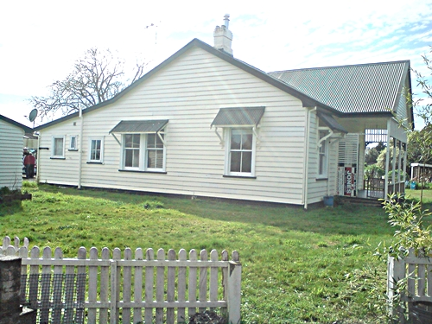

Workshop Facilitator
Ian Mayes
Hamilton City Council, Eco Design Advisor, Builder.

Workshop Content

- Techniques to preserve maximum value from materials
- How to spend less on landfill by wasting less
- What and where to recycle for best value

Workshop Timeline
Briefing and Assignment |  | Tues, 26th Feburary | 6pm-7.30pm
Deconstruction | Internal - fittings/walls etc. | Sat, 2nd Mar | 8am - 5pm
 | Exterior - doors and floors etc | Sat, 9th Mar | 8am - 5pm
 | Roof, frame, piles | Sat, 16 Mar | 8am - 5pm

Cost $45 for ALL four days
Day or part day by arrangement
Provided Hard hats and Refreshments
Bring your own Tools, safety boots, safety glasses, Lunch.
Registration
Sustainable Cambridge 07 8237433 or Tim Bailey 021 1467145
info@sustainablecambridge.co.nz
Registration will be confirmed upon receipt of registration fee.
A Cambridge Community Garden Fundraiser supported by Sustainable Cambridge, Waipa District Council, Hamilton City Council and Waipa Networks


