Utilising Resources
Solar power
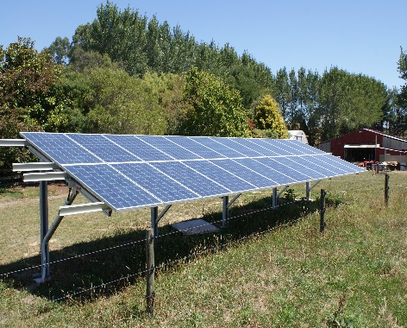
6Kw solar array, grid tied using micro-inverter technology.
Aim to zero power bill for home and property.
Presentation / discussionby resident electrician of our system and other types of systems – how they work, myths, solutions.
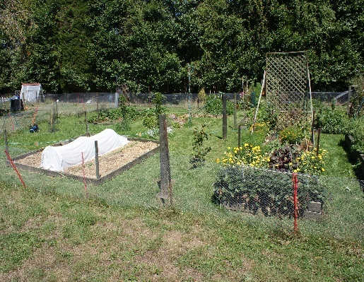
Paddock to food garden in less than 18mths
See how a paddock has been transformed into a fruit and veg garden to feed the family, with low cost and time inputs.
Discuss examples of different methods, success and lessons. Also browse information table.

March 29th 1pm-2.30pm
85 Te Puea Rd, Tikitere, Rotorua
Cost: n/c, but bring cash for bagpiping / drumming buskers, For Sale: pine cones, barley straw, mini bailage, order firewood …
Contact:bentleysnz@gmail.com

